HD 66428

HD 66428 is a 1.05 M☉, G5 star27. Using 99 RV HIRES measurements obtained between 2000 and 2019, The CL survey reported a GP (HD 66428b) signal with a period of days, a minimum mass of 3.19 ± 0.11 MJup and an eccentricity of and a LPGP (HD 66428c) signal with a period of days, a minimum mass of MJup and an eccentricity of .

In the present study, in addition to the CL survey's dataset, 28 RV HARPS measurements obtained between 2004 and 2015 were used. DPASS and MCMC (1000 walkers and 400000 iterations) were used to fit the data. The properties found for HD 66428b reported in the CL survey were within the error bars associated with the values found in the present analysis. For HD 66428c, a period of 9107 days, a minimum mass of 2 MJup and an eccentricity of 0.19 were found with DPASS, with a corresponding rms of residuals of 2.8 m/s, and a period between 33000 and 167000 days, a minimum mass between 42 and 202MJup and an eccentricity between 0.43 and 0.78 were found using MCMC. As the RV curve of HD 66428c only covers a minimum, the period (or *a*) is actually not well constrained.

To explore the range of possible values, the semi-major axis was fixed to different values and the data fitted with DPASS. *a* up to 190 au do not significantly change the rms of the residuals (3.3 m/s against 2.8 m/s with *a* left free). In this case (referred to as constrained *a*), the minimum mass is 4 MJup and the extremely high eccentricity is 0.95.

To test the impact of the stellar RV offset, it was also fixed to different values and the data, once corrected for the instrumental offsets for clarity purposes, were fitted with DPASS. It appears that stellar RV offset up to 300 m/s does not significantly change the rms of the residuals (3 m/s against 2.8 m/s with stellar RV offset free). In this case (referred to as constrained offset), the semi-major axis is 48 au, the minimum mass is 52 MJup and the eccentricity is 0.63.

The fits are shown in Fig 1, and the corner plot in Fig 2, and the results summarized in Table 1.

Conclusion: The properties found in the CL survey for HD 66428c are not confirmed. Depending on its semi-major axis and/or stellar RV, the companion could be a brown dwarf. Additional data are needed to further constrain its orbital properties.

Figure 1: Top left: fit of the HD 66428 RV with DPASS. Red - Hir94, green - Hir04, blue - H03. The blue curve shows the best fit. Top right: fit of the HD 66428 RV with DPASS, with the minimum *a* fixed at 190 au. The points are the same as on the left. The blue curve shows the best fit. Bottom left: fit of the HD 66428 RV with DPASS, with a stellar RV offset subtracted fixed to 300 m/s. Black points correspond to the data corrected for the instrumental offsets. The blue curve shows the best fit. Bottom right: fit of the HD 66428 RV using MCMC. The black curve shows the best fit. The colorbar corresponds to the log-likelihood of the fits.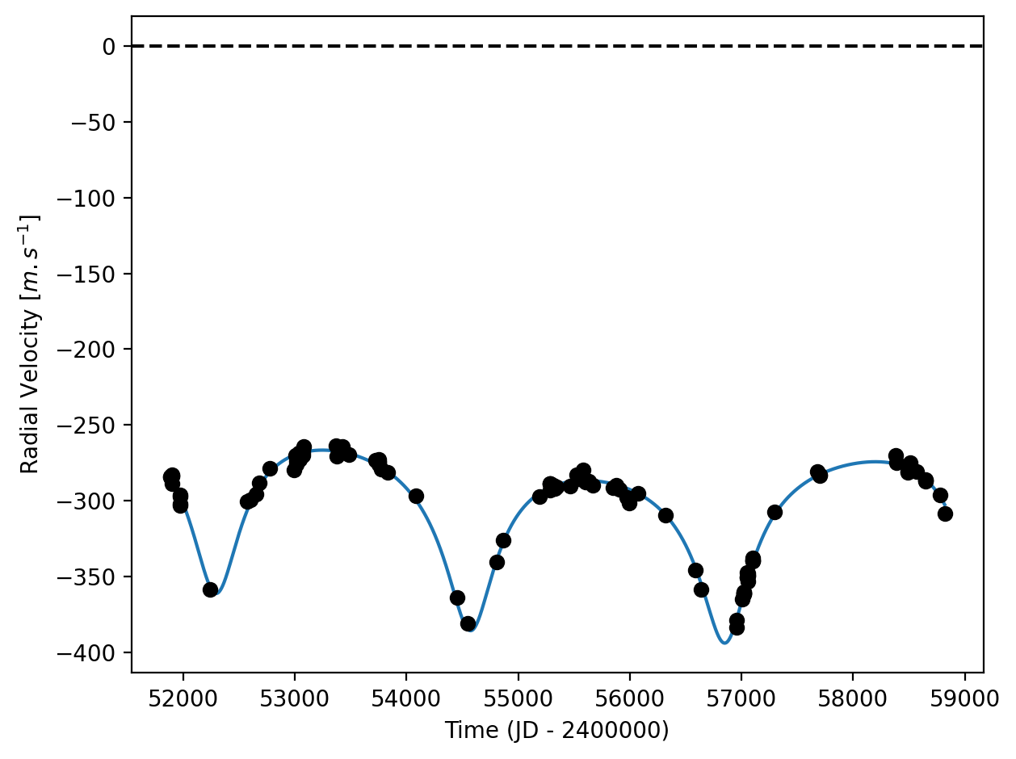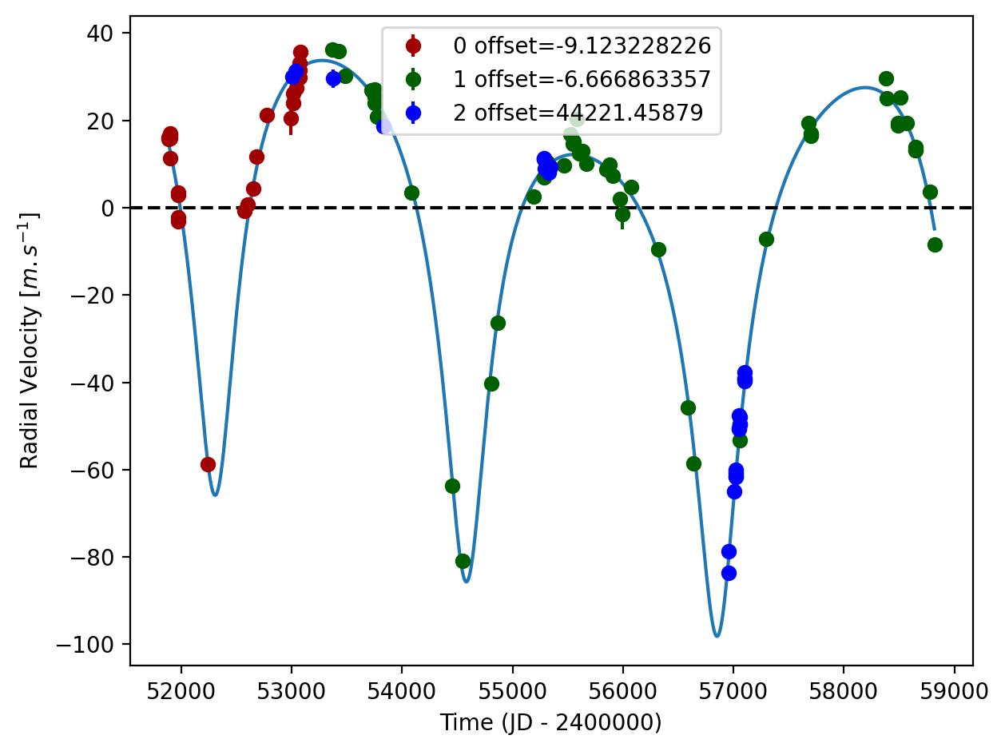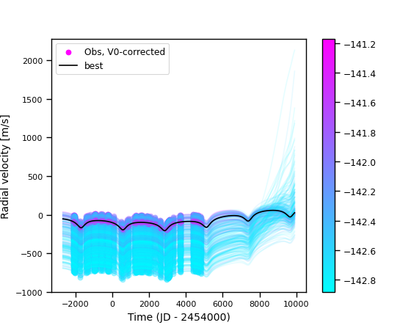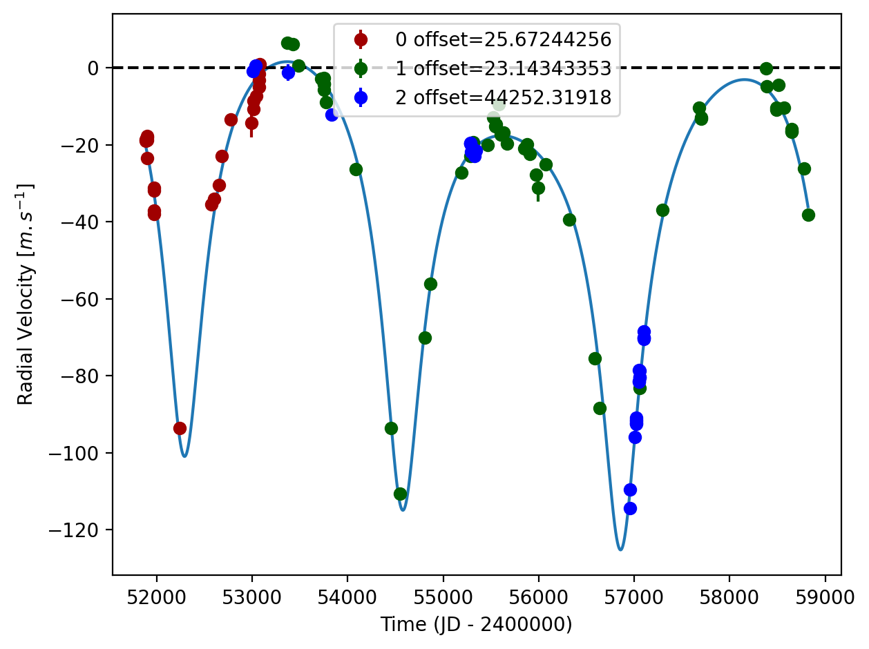

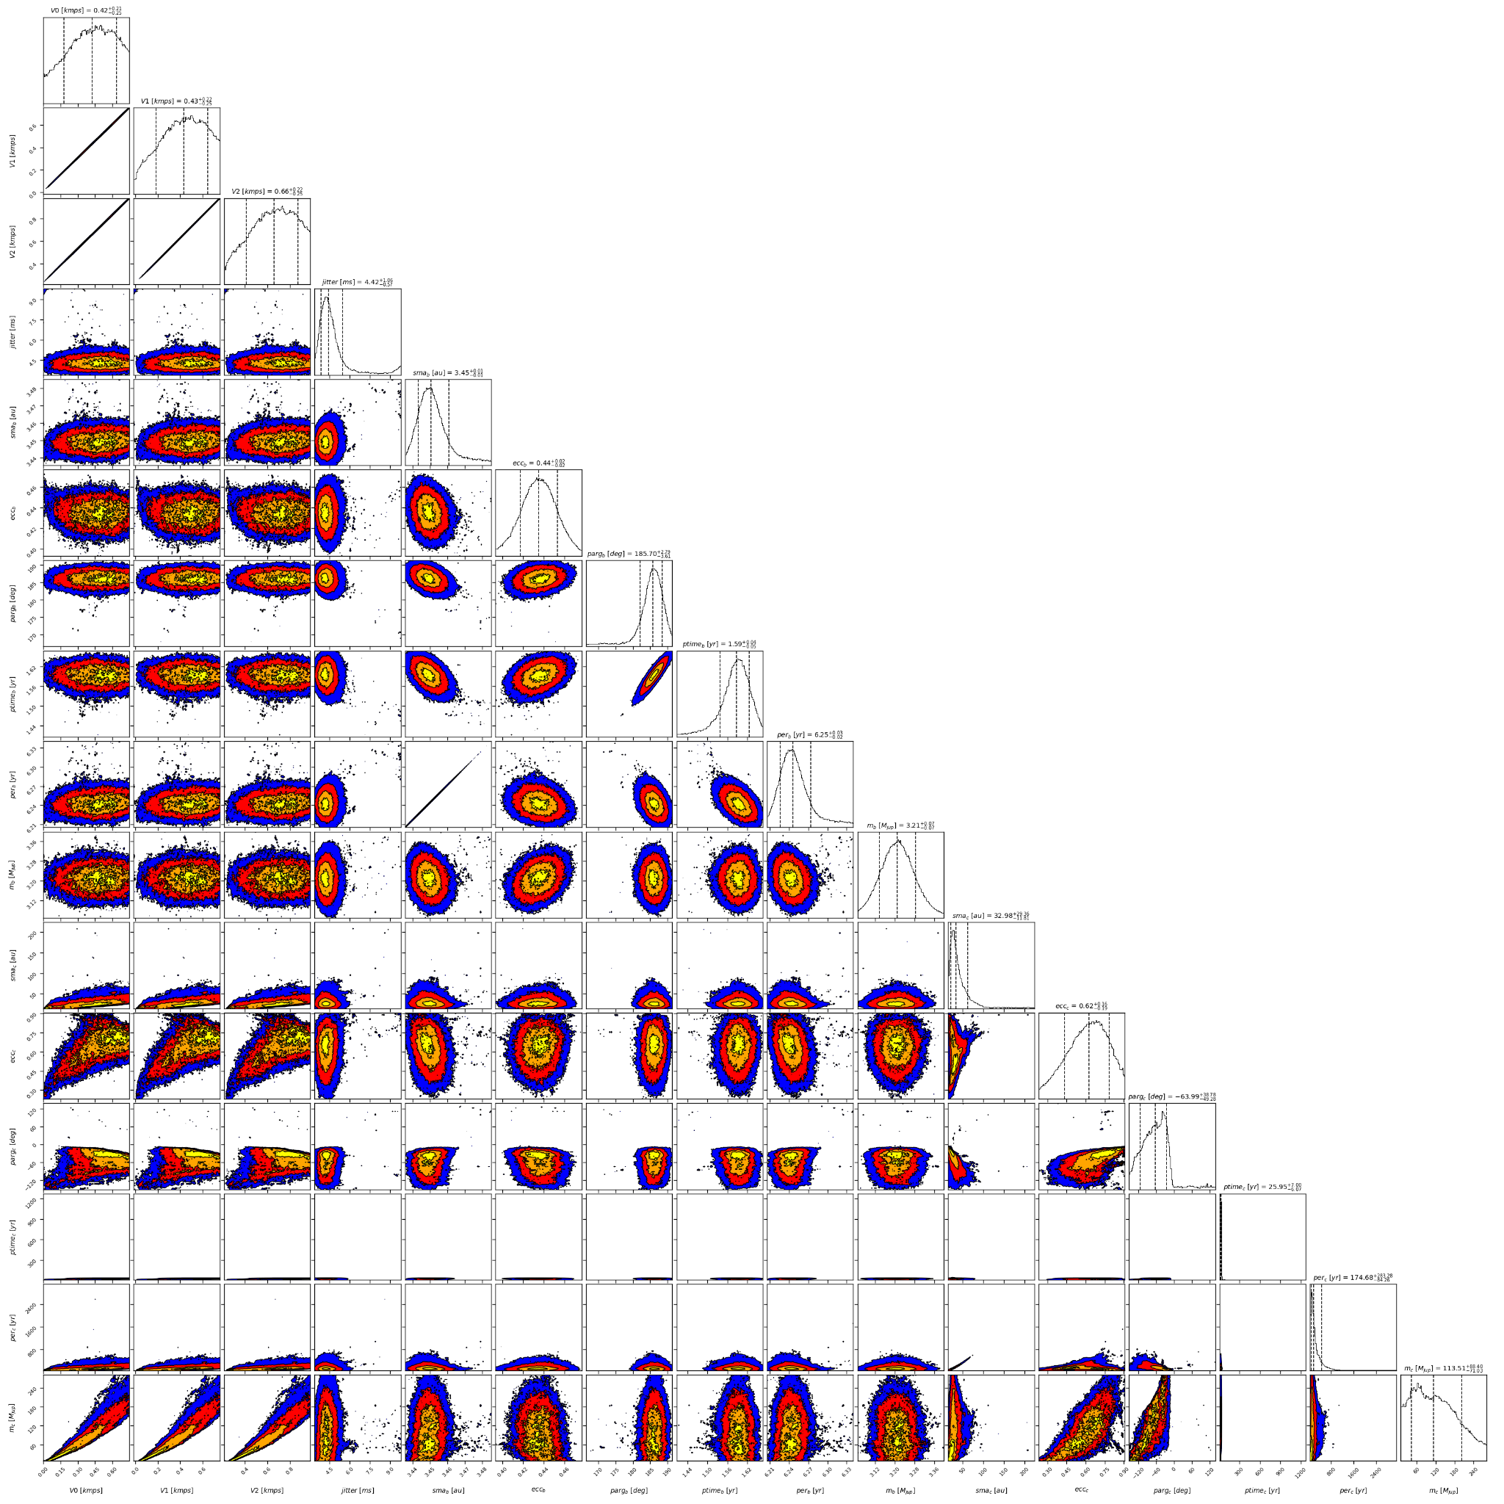

Figure 2: Corner plot of posteriors for the two-planets model MCMC fit of HD 66428 RV data.

| Parameter | Priors | | | | Posteriors | | | | CL survey |
| --- | --- | --- | --- | --- | --- | --- | --- | --- | --- |
|  | DPASS | | | MCMC | DPASS | | | MCMC |  |
|  | Free priors | Constrained *a* | Constrained offset | Free priors | Free priors | Constrained *a* | Constrained offset | Free priors |  |
| *a* (au) | b: [0,100]  c: [0,100] | b: [0,100]  c: up to 190 | b: [0,100]  c: [0,100] | b: [1,5]  c: [6,1000] | b = 3.44  c = 8.7 | b = 3.45  c = 190 | b = 3.45  c = 48 | b = 3.45 ± 0.01  c = 21 – 62 | b =  c = |
| Msin(i) (MJup) | b: [0,100]  c: [0,100] | b: [0,100]  c: [0,300] | b: [0,100]  c: [0,100] | b: [0,10]  c: [1,1000] | b = 3.2  c = 2.0 | b = 3.2  c = 4.0 | b = 3.2  c = 52 | b = 3.21 ± 0.07  c = 42 – 202 | b = 3.19 ± 0.11  c = |
| Eccentricity | b: [0,0.95]  c: [0,0.95] | b: [0,0.95]  c: [0,0.95] | b: [0,0.95]  c: [0,0.95] | b: [0,0.95]  c: [0,0.95] | b = 0.46  c = 0.19 | b = 0.46  c = 0.95 | b = 0.43  c = 0.63 | b =  c = 0.43 – 0.78 | b =  c = |
| Instrumentals offsets (km/s) | [-60,60] | [-60,60] | up to 0.3 | Hir94: [-1,1]  Hir04: [-1,1]  H03: [43,45] | Hir94: -0.009  Hir04: -0.007  H03: 44.222 | Hir94: 0.026  Hir04: 0.023  H03: 44.252 | 0.3 | Hir94: 0.178 – 0.638  Hir04: 0.184 – 0.646  H03: 44.412 – 44.873 |  |
| Stellar jitter (m/s) | [0,40] | [0,40] | [0,40] | [0,10] | 3.6 | 4.2 | 3.8 |  |  |
| Argument of periastron (°) | b: [0,360]  c: [0,360] | b: [0,360]  c: [0,360] | b: [0,360]  c: [0,360] | b: [0,360]  c: [0,360] | b = 183  c = 244 | b = 179  c = 187 | b = 184  c = 249 | b =  c = 247 – 335 |  |
| Phase | b: [0,1]  c: [0,1] | b: [0,1]  c: [0,1] | b: [0,1]  c: [0,1] | b: [0,1]  c: [0,1] | b = 0.00  c = 0.33 | b = 0.89  c = 0.06 | b = 0.94  c = 0.52 | b = 0.25 ± 0.01  c = 0.06 – 0.34 |  |

Table 1: HD 66428. Summary of priors and posteriors obtained with DPASS and MCMC, compared to the properties reported by the CL Survey.

References

1. Rosenthal, L. et al. The California Legacy Survey. I. A Catalog of 178 Planets from Precision Radial Velocity Monitoring of 719 Nearby Stars over Three Decades. *Astrophys. J.* *Suppl. Ser.* 255, 8 (2021).